PartnerLoop Creator Portal — UI/UX Audit
Oct 14, 2026 · @Hamad
The creator portal works and its numbers are right, but it looks like a starter template and has no visual hierarchy. This audit lists 71 issues across the portal, 25 of them major, each with an ID, the reason it matters, a direction, and a severity you can change.
The five that shape the redesign most:
- No design system beyond colour. No type scale, no shared buttons or cards, a bordered and shadowed card around everything, and default Tailwind blue as the brand (DS-1 to DS-4).
- The Overview has no hierarchy. Seven equal tiles with one stranded, a trend panel that repeats them, a mouse-only chart, and no next step once a creator has sales (OV-1 to OV-5).
- Navigation breaks on phones and with several programs. The active tab scrolls out of view, and the program switcher looks like a second tab row with no status (SH-1, SH-2).
- The merchant's brand is missing. Creators sell for a store, but the shell says PartnerLoop and the join page has no logo (SH-3, AU-1).
- Money pages report but don't help. A pending payout looks paid, Earnings has no summary or filters, and nothing explains how payment happens (PA-1, EA-1, EA-2, HE-2).
How it was done: every page was opened as six made-up creators (active, pending, rejected, paused, brand-new, in two programs) at 360, 390, 768, 1024 and 1440px, in light and dark, and the code behind each page was read. Each area below has its own table; “Order of work” says what to tackle first; the last section lists behaviours the redesign must keep.

Layout direction
Use an app shell with a persistent left sidebar and a fluid 12-column content area. It removes the empty side margins, gives the product room to grow into analytics, referrals and campaigns, and replaces both the tab strip and the program pills with one navigation.
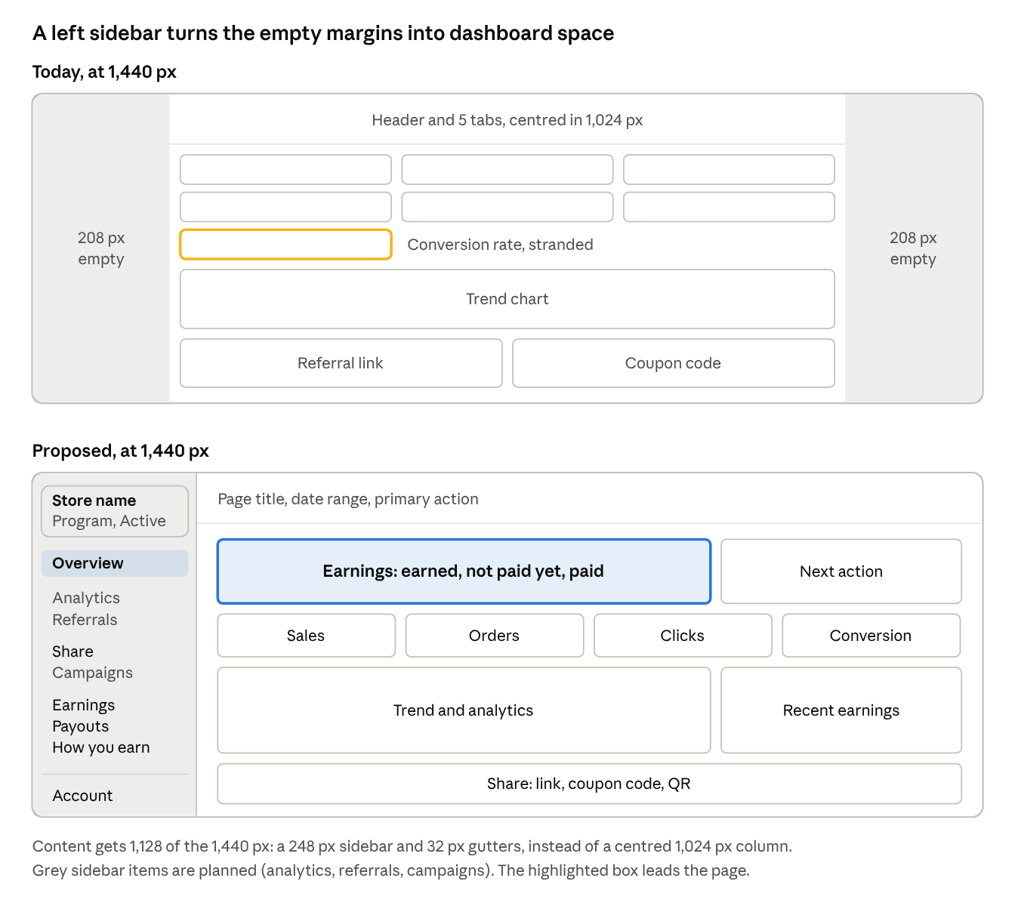
Overview at 1,440 px · today vs proposed, same scale
The sidebar takes 248 px on the left; the content grid beside it uses the rest instead of leaving two empty margins.

Why a sidebar
- It fills the screen. Today's centred 1,024 px column leaves 208 px empty on each side at 1,440 px, and 448 px each side at 1,920 px. With a 248 px sidebar and 32 px gutters, content gets 1,128 px at 1,440, laid out on a grid.
- It scales. A sidebar holds 10–15 destinations in labelled groups; a top tab strip runs out at about six, and the portal already has five tabs plus Settings.
- One place for context. The store-and-program switcher sits at the top with its status (fixes SH-1, SH-3); the account menu sits at the foot (SH-4, SH-5).
- It's familiar. It is the shape of Shopify admin, which every merchant already uses, and of most affiliate and creator dashboards.

Navigation structure
Group | Today | Planned
Home | Overview | —
Performance | — | Analytics, Referrals
Promote | Share (links, QR) | Campaigns
Money | Earnings, Payouts | —
Program | How you earn | —
Sidebar foot | Account menu: Settings, theme, Sign out | Help
Open question: what “Referrals” means needs settling before it gets a page. Today a referral is a referred order, which Earnings already lists; if it means creators inviting other creators, it belongs under Promote.

Widths and breakpoints
Screen width | Sidebar | Content
1,280 px and up | Expanded, 248 px: icons, labels, group headings | 12-column grid, 32 px gutters, dashboards up to 1,440 px wide, aligned to the sidebar rather than centred
1,024–1,279 px | Collapsed rail, 72 px: icons with tooltips, expands on click | 12-column grid, 24 px gutters
Under 1,024 px | Hidden; a menu button in a slim top bar opens it as a drawer (focus trapped, closes on Esc or backdrop) | One column, 16 px gutters; the top bar keeps the page title, the program and the Share action
No bottom tab bar on phones, by decision. Reading and form pages (How you earn, Settings) keep their text near 720 px for line length, but sit in two columns on wide screens rather than one narrow centred column. Beyond about 1,720 px (sidebar plus 1,440), the extra width falls to the right of the content only.

The Overview on the grid
- Earnings panel across 8 columns (earned, not paid yet, paid out) beside the next-action card (4).
- Four performance figures, 3 columns each: sales, orders, clicks, conversion. Nothing stranded.
- Trend chart (8) beside recent earnings (4).
- A share strip: link, coupon code, QR.
Below 1,024 px the same order stacks into one column, with the performance figures two to a row.

Visual direction
- Light first. A warm off-white canvas and white content surfaces; the sidebar on the canvas tone with a hairline edge, not a dark panel.
- One restrained accent, indigo or violet: primary buttons, the active nav item, the main chart series. Status colours only ever mean status.
- Hierarchy from type and space, not boxes. A 5–6 step type scale, cards only for real groups, one shadow level.
- Numbers set in tabular figures, with the earnings figure the largest type on the page.
- Dark mode as lifted charcoal, not black, with a System / Light / Dark choice in the account menu.
- The merchant leads. Store logo and name in the switcher and on the join page; PartnerLoop as a small mark at the foot of the sidebar.

How to see the portal yourself
Run the creator portal locally and sign in with the two test creators on the dev database. Before the first run, apply the pending schema update, or every dashboard page errors after sign-in.
cd partner-loop-creator-growth
npx prisma db push
cd ../creators-panel
npm run schema:sync
npm run dev # http://localhost:3001
Login | Password | State it shows
sarah@example.com | partnerloop123 | Active creator with data: 3 orders, 2 payouts, a declined commission, a product override
mike@example.com | partnerloop123 | Pending application: the "under review" screen
Other states have to be set up from the Shopify app (Creators page): approve Mike for the day-one experience, reject him for the rejected screen, deactivate Sarah for the paused membership banner, or set a program to Inactive for the paused program banner. Both programs are currently Inactive, so Sarah sees that banner today.
Page | Route | What it is for
Join | /join/<programId> | Public signup for one merchant's program
Sign in | /login | Email and password
Overview | /dashboard | Totals, trend, link and code, recent earnings
Earnings | /dashboard/earnings | Every referred order and its commission
Payouts | /dashboard/payouts | Payments from the merchant
How you earn | /dashboard/program | Rates and rules
Share | /dashboard/links | Link builder, product links, QR code
Settings | /dashboard/settings | Name, email, password, payout details
Screenshots in this audit come from a private local copy with made-up creators (Sarah, Mike, plus Omar paused, Rina rejected, Ali brand-new), taken at 390 px and 1280 px, light and dark.

Design system and visual language
The colour tokens are sound and both themes work, but nothing else is systematised: type, spacing, radius, elevation and components are hand-written page by page. That is most of why the portal looks like a template.
What exists: semantic colour tokens in app/globals.css (canvas, surface, line, ink, brand, and warn/info/ok/bad/neutral status pairs), redefined for dark mode, and a hand-drawn icon and illustration set that uses them.
ID | Problem | Why it matters | Direction | Severity
DS-1 | No type scale. Sizes are chosen per element: 13 uses of text-[11px], 15 of font-extrabold, 11px bold uppercase labels on almost every card | Heavy, shouty look; 11px labels are hard to read | 5–6 type tokens (display, title, body, label, caption); retire the 11px caps labels | Major
DS-2 | No shared components. The primary button's classes are pasted 11 times; three pages each define their own Card/Section | Every page drifts; a restyle means dozens of edits | Build Button (primary, secondary, ghost, danger), Card, PageHeader, Section, Stat once | Major
DS-3 | Every block is a white card with border and shadow (24 cards, 22 shadows) | Nothing leads; pages read as a stack of equal boxes | Cards only for real groups; spacing and dividers inside them; one elevation token | Major
DS-4 | Brand is default Tailwind blue (#1d4ed8); the "P" logo and the join panel are hard-coded blue gradients outside the tokens (15 raw palette classes) | Reads as a starter template | Pick an accent (the brief suggests a restrained indigo/violet); put the logo and join panel on tokens | Major
DS-5 | Dark mode is near-black (#09090b) with cards one step lighter; it only follows the OS setting | Heavy; surfaces barely separate | Lift the dark surfaces; add a System / Light / Dark switch | Minor
DS-6 | Status badges are 11px bold pills | Status is the most-scanned thing in the portal | One larger Badge with a dot or icon, used everywhere | Minor
DS-7 | No radius, spacing or shadow tokens (rounded-2xl cards, rounded-lg controls, picked per element) | Inconsistent rhythm between pages | Tokens for radius, spacing and 1–2 shadows | Minor
DS-8 | No reduced-motion handling (28 transitions, a pulsing skeleton) | Accessibility expectation | Wrap motion in motion-safe: | Minor
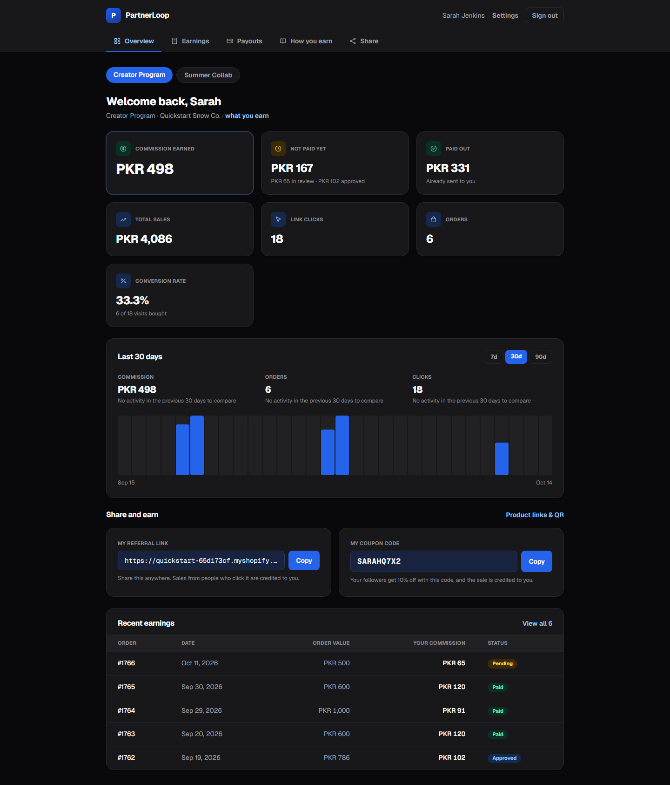
Dark mode today (1440px): near-black page, cards one step lighter, every block boxed the same way (DS-3, DS-5).

App shell and navigation
The shell stacks two navigation rows that look alike, hides the merchant whose products the creator sells, and loses the active tab on phones.
ID | Problem | Why it matters | Direction | Severity
SH-1 | The program switcher is a row of pills under the tabs that looks like a second tab row, and shows no status (pending, active, paused) | A creator in several programs can't tell which one they are in, or which ones are live | Switcher at the top of the sidebar: store name, program, status badge (see Layout direction) | Major
SH-2 | On a 390px phone only Overview, Earnings and Payouts fit; on Share or How you earn the active tab is scrolled out of sight | No sense of place on the device most creators use | Left sidebar; on phones it opens as a drawer from a slim top bar that always shows the page title (see Layout direction) | Major
SH-3 | The header says PartnerLoop; the merchant appears only in a small grey meta line on Overview | Creators work for the brand; the brand they promote is barely visible | Lead with the store (name, later a logo) in the program context; PartnerLoop as a quiet "powered by" | Major
SH-4 | On Settings no tab is highlighted and the header link has no active state | Users lose their place | Account menu at the foot of the sidebar (Settings, theme, Sign out) with an active state | Minor
SH-5 | Name, Settings and Sign out are three loose items; Sign out is the only outlined control in the header | Most visual weight on the least-used action | Fold all three into the account menu | Minor
SH-6 | One loading skeleton, shaped like the Overview, serves all six pages | Earnings and Payouts flash a wrong layout while loading | A skeleton per page (loading.tsx per route) | Minor
SH-7 | Content sits in a 1024px column at every width | Fine for text pages; tables and the chart are cramped at 1440px while the margins sit empty | Fluid 12-column grid beside the sidebar, dashboards up to 1,440 px (see Layout direction) | Minor

Overview dashboard
The Overview has the right numbers but no hierarchy: seven equal tiles with one stranded, a trend panel that repeats them, and no next step once a creator has sales.
Today, top to bottom: page title “Welcome back, Sarah”, a meta line (program · store · “what you earn” link), 7 tiles (Commission earned, Not paid yet, Paid out, Total sales, Link clicks, Orders, Conversion rate), a “Last 30 days” panel with a 7d/30d/90d picker, three period figures and a bar chart, “Share and earn” (referral link and coupon code), and the last five earnings.
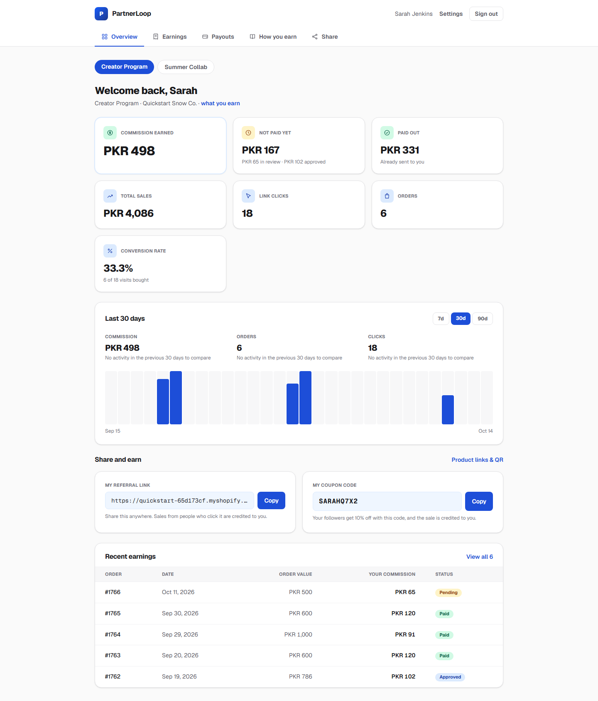
Overview at 1440px: Conversion rate stranded on the third row (OV-1), the 30-day panel repeating the tiles (OV-3), a chart with no scale (OV-4), program pills that look like tabs (SH-1).
ID | Problem | Why it matters | Direction | Severity
OV-1 | Seven tiles in a 3-column grid leave Conversion rate alone on a third row; at 768px it is stranded again, and Paid out lands beside Total sales, splitting the money and reach colour groups | Looks broken; the brief's “stranded card” | One money panel (Earned = Not paid yet + Paid out), then a balanced row of four performance figures (sales, orders, clicks, conversion) | Major
OV-2 | Money and performance tiles look the same; Commission earned is set apart only by a faint ring | The number creators come for doesn't lead | Earnings as the hero: large figure, paid and unpaid shown as a split | Major
OV-3 | The “Last 30 days” panel repeats the tiles (PKR 498, 6 orders, 18 clicks) when all activity is recent, and prints “No activity in the previous 30 days to compare” three times | Redundant; reads like an error | Show period figures only beside the chart, with one comparison line; keep lifetime and period clearly labelled | Major
OV-4 | The chart's values exist only as hover tooltips (title); no axis, no scale, only the first and last dates; a grey track behind every empty day | Unreadable on phones and to keyboard and screen-reader users | A scale or max line, tap/focus to show a value, a visually hidden data table, quieter empty days | Major
OV-5 | No next action for a creator who already has sales | The page reports but never guides | One card chosen from real state: payout details missing, money awaiting payment (“PKR 102 is in PL-0004”), program paused, no sale in 30 days | Major
OV-6 | Title is a greeting; program, store and the “what you earn” link share one grey line | No page identity; the key link looks like small print | Page header: “Overview”, program with a status chip, store name; links as buttons | Minor
OV-7 | The referral link is truncated in a monospace field; the full link is never visible | Creators want to see what they share | Readable preview (domain + ?ref=CODE) or an expand control | Minor
OV-8 | The recent-earnings preview spreads five columns across 1024px | Hard to scan | Compact list: order, date, status, commission; “View all” to Earnings | Minor
OV-9 | Brand-new creators still get seven zero tiles and an empty chart (now below their link) | The page feels dead on day one | Hide zero performance figures until the first click; keep the day-one checklist | Minor

Earnings
Earnings is accurate and explains every row well, but it is only a table: no summary, no filters, and no way to check the rate an order earned.
Worth keeping as is: one row per order, cards under 768px and a table above, a status badge with a one-line explanation (hold date, payout number, the merchant's decline reason), refund notes that tell “refunded before payout” apart from “owed back”, struck-through declined amounts, and 25-row pagination.
ID | Problem | Why it matters | Direction | Severity
EA-1 | No summary above the list | Creators must add up statuses themselves | A strip of totals by status (in review, approved, paid, declined) that doubles as filters | Major
EA-2 | No status filter, no order search, no date range | Gets hard to use past a page or two | Status chips, order-number search, date range | Major
EA-3 | The rate an order earned at is not shown (PKR 120 on PKR 600 is the 20% product rate; PKR 102 on PKR 786 is the 13% standard) | Creators can't check the maths | Show the effective rate per order; name the rule where the commission's stored terms allow | Minor
EA-4 | Payout references (“Paid in PL-0006”) are plain text | No way to jump to that payment | Link to the payout on the Payouts page | Minor
EA-5 | The header shows “6 orders” and “Showing 1–6” together | Redundant | One count; the range only when there is more than one page | Minor
EA-6 | Long dates on every row (“Sep 30, 2026”) | Noise in the densest column | Short dates; full date on hover or in the expanded row | Minor
EA-7 | No export | Creators reconcile income for tax | CSV download (a new feature, so confirm scope first) | Minor

Payouts
Payouts shows every field a creator needs to check a payment, but a pending payout looks almost exactly like a paid one, and the page has no totals.
Each payout is a card: number (PL-0004), status badge, created or paid date, amount, then Method, Reference and Covers (order numbers), and the merchant's note if any. A red “Balance owed back” card sits on top when a refund landed after payment.
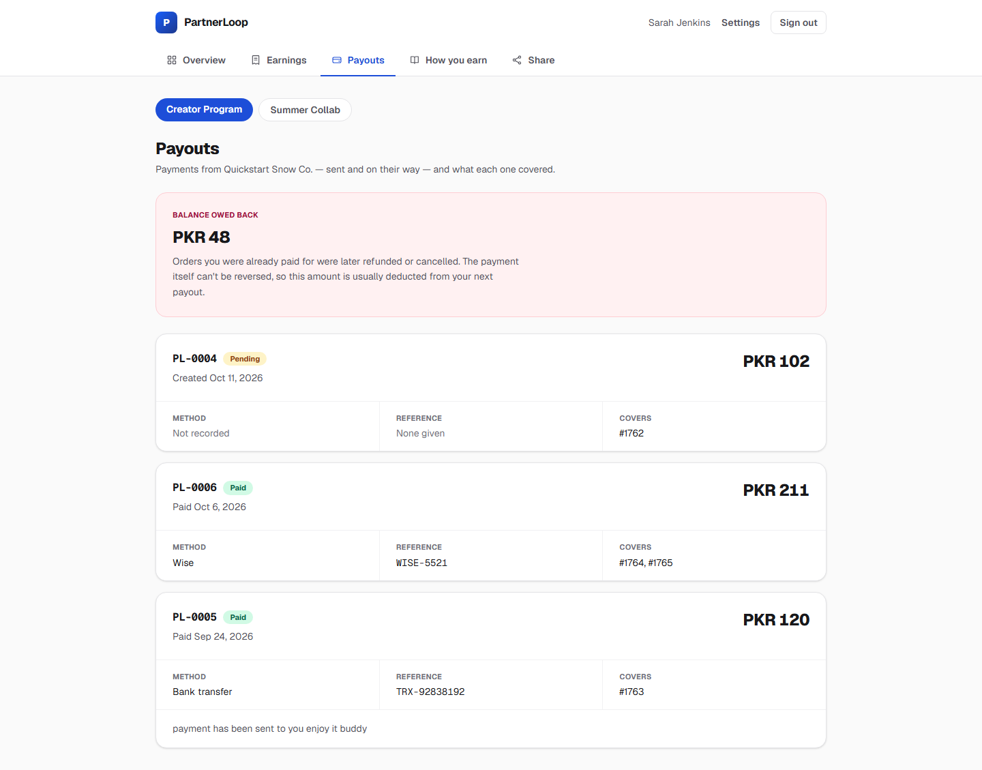
Payouts at 1440px: the pending PL-0004 looks like the paid ones (PA-1); the owed-back card is a full red alert (PA-3); the note at the bottom is unlabelled (PA-6).
ID | Problem | Why it matters | Direction | Severity
PA-1 | A pending payout (PL-0004, “Created Oct 11”) has the same card and the same large amount as paid ones; only a small amber badge differs | A creator can read money as received when it hasn't been sent | Separate “On its way” from “Paid”: group or style pending payouts differently, and say “not sent yet” in words | Major
PA-2 | No totals (paid to date, awaiting payment) | Creators add it up themselves | Summary strip at the top, consistent with the Overview money figures | Minor
PA-3 | “Balance owed back” is a full red alert card | Alarming for a routine deduction | A calmer warning panel: amount, why, “deducted from your next payout” | Minor
PA-4 | “Covers #1764, #1765” is plain text | Can't see what each order contributed | Link the orders to Earnings and show each one's amount | Minor
PA-5 | Three bordered detail cells per card, with “Not recorded” and “None given” filling empty ones | Bulky; empty values take full cells | Compact rows on desktop; omit or mute empty fields | Minor
PA-6 | The merchant's note sits unlabelled at the bottom of the card | Reads as system text | Label it as a note from the store | Minor

How you earn
The content is correct and complete, but it is six stacked full-width cards of rules with no worked example, and it says nothing about how payment actually happens.
Sections today, each shown only when the program has that rule: standard rate, rates by customer type, specific products, “which rate wins”, good to know (minimum order, hold period), how sales are credited (link, coupon).
ID | Problem | Why it matters | Direction | Severity
HE-1 | No worked example | Precedence is abstract until you see it applied | “A PKR 1,000 order from a first-time customer, including a Snowboard…”, computed from the program's real rules | Major
HE-2 | Nothing on how and when payment happens: manual, by the merchant, to the details in Settings, after the hold period | The most common creator question | A “Getting paid” section linking to payout details | Major
HE-3 | Six full-width cards with 11px caps labels; at 1440px each rate sits about 800px to the right of its label | A wall of boxes, long eye travel | One page with a rates table, rates next to their labels | Minor
HE-4 | Doesn't say that a code entered at checkout beats a link | Creators can't tell why a sale went to someone else | Add it to “How sales are credited” | Minor
HE-5 | A 0% product reads “0% of the sale” here but “Earns no commission” on Share | Inconsistent wording | Same wording on both pages | Minor
HE-6 | Product rates don't link to sharing that product | Dead end | Link each product to its entry on Share | Minor

Share
Sharing works and is safe, but it's built for copying on a desktop: there's no native share on phones, the QR code can't be downloaded, and two cards produce the same link.
Today: store link card, coupon code card, “Link to any page” builder (paste a URL or path, get a tracked link, show a QR code), then products with their own rate, each with a ready-made link.
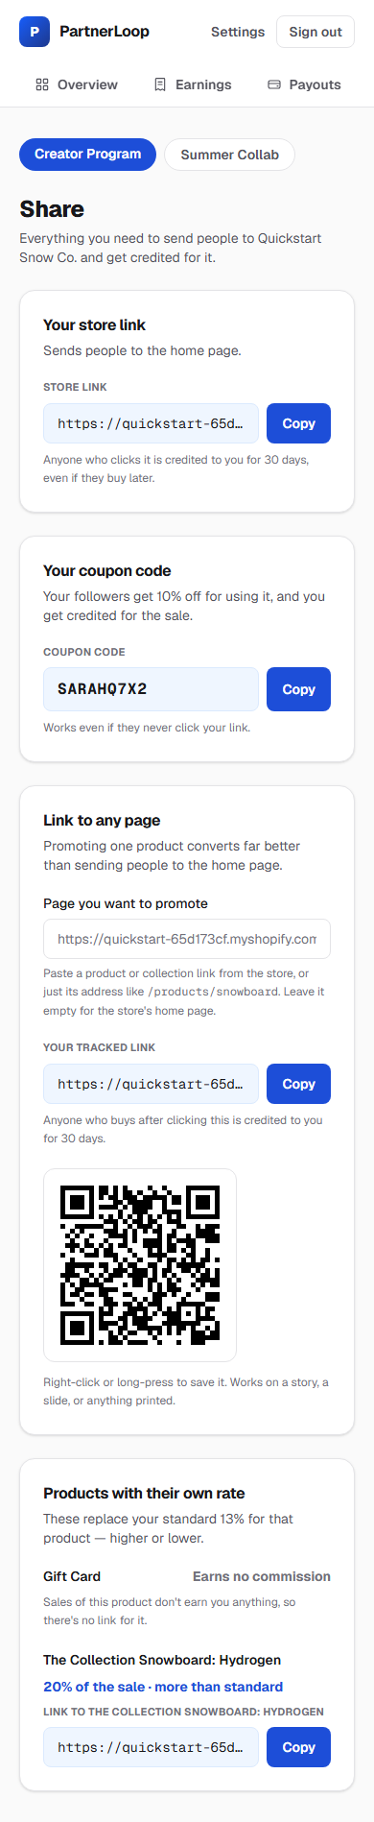
Share on a 390px phone: the active Share tab is off screen (SH-2), every link truncated (SR-4), a save-by-long-press QR (SR-2), four primary Copy buttons (SR-5).
ID | Problem | Why it matters | Direction | Severity
SR-1 | No native share button (Web Share API) | Creators share from their phones, to WhatsApp and Instagram | A Share button using navigator.share, falling back to Copy | Major
SR-2 | The QR code can't be downloaded (“Right-click or long-press to save it”), and it's small and unbranded | Clumsy for stories and print | Download PNG/SVG; a larger code; optional store logo | Minor
SR-3 | “Your store link” and the builder both produce the home-page link by default | Two cards, same output | One builder that starts on the home link | Minor
SR-4 | Every link is truncated in a monospace field | Can't check before sharing | Readable link preview, or an expand control | Minor
SR-5 | Up to seven Copy buttons, all primary | No focal point | One primary action per card; Copy as secondary | Minor
SR-6 | Product entries are a name and a rate: no image or price | Hard to choose what to promote | Needs product images and prices, which the portal doesn't store yet (data work) | Minor

Account settings
Settings works well — each form validates, marks the failing field, announces the result and moves focus to it — but it is one long column of four forms with four identical buttons, and it lacks the account basics creators expect.
ID | Problem | Why it matters | Direction | Severity
ST-1 | Four forms in one long column, each in its own card with a primary button; fields stop at 448px, leaving the right half of a desktop empty | No hierarchy; long scroll | Two-column layout on desktop (section title and description left, form right); secondary buttons except where it matters | Minor
ST-2 | “What you sign in with” appears twice (section description and field hint) | Noise | Keep one | Minor
ST-3 | Payout method is free text | Merchants see “wise”, “Wise”, “WISE transfer” | Select with common methods plus Other (still saved as text) | Minor
ST-4 | No show-password toggle | Typos on phones | Show/hide control on password fields | Minor
ST-5 | No account deletion, data download or notification preferences | Deletion is a privacy expectation; notifications need email (not built) | Design the slots now; behaviour waits on decisions (tests.md H1, H13) | Major

Signup, sign-in and status screens
The join page is the first thing a creator ever sees, and it sells the program weakly; the status screens are clear but leave the rest of the portal clickable and empty.
Screens: join (/join/<id>: blue program panel left, form right; one-click “Join as …” when already signed in), sign-in, the pending / rejected / paused-membership takeovers, the amber “program is paused” banner, and a branded 404.
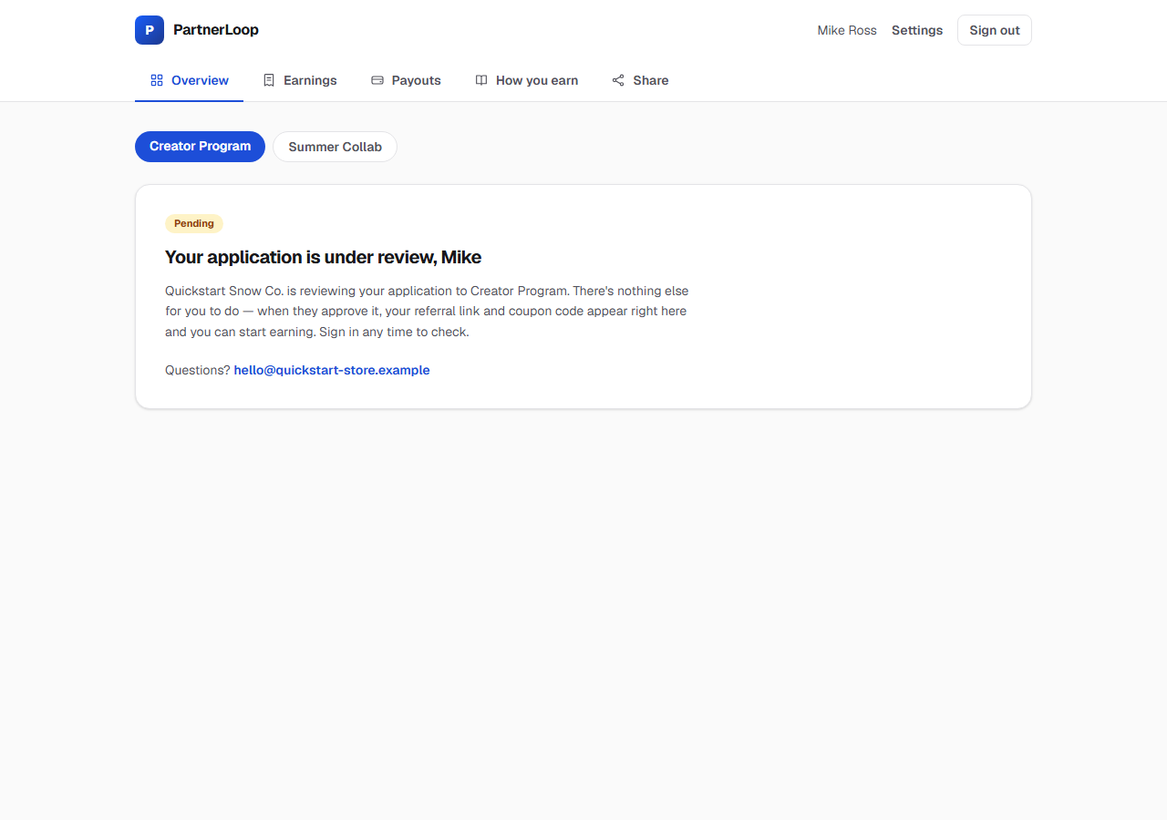
A pending creator: five clickable tabs that all show this message (AU-5), nothing to do while waiting (AU-6), and program pills with no status (SH-1).
ID | Problem | Why it matters | Direction | Severity
AU-1 | The join page has no merchant branding: no logo, image or colour, and the store name falls back to its handle (“by quickstart-65d173cf”) until the merchant opens their dashboard once | The first impression is a template, for someone deciding whether to work with this brand | Merchant logo and name on the join page and in the shell (logo needs data the portal doesn't have yet) | Major
AU-2 | It states only the standard rate (“13% of every sale you refer”), not higher product or new-customer rates, the shopper discount, or the hold | Undersells the program | “Up to 20% · 15% on first-time customers · your followers get 10% off” from real rules | Minor
AU-3 | No privacy notice or terms at signup | The portal collects names, emails and bank details | Links once the wording exists (tests.md H12); design the space now | Major
AU-4 | No “Forgot password” | A locked-out creator has no way back | Blocked on email (tests.md H1); design the 6-digit-code flow now | Major
AU-5 | Pending, rejected and paused screens keep all five tabs clickable, and every tab shows the same message | Dead navigation | Hide or disable program tabs that can't show anything; keep Earnings and Payouts for paused creators | Minor
AU-6 | The pending screen gives nothing to do while waiting | No momentum before approval | Preview the program's terms; prompt for payout details; show when they applied | Minor
AU-7 | The “program is paused” banner is a loud amber box above every page | Correct but alarming; the brief asks for a restrained panel | A quieter status panel with what still works and what doesn't | Minor
AU-8 | Sign-in is a bare card with no product or merchant context | Generic | Minimal branded sign-in | Minor

Responsive behaviour
No page scrolls sideways at any width checked (360, 390, 768, 1024, 1440px), but phones get a very long Overview and lose the tabs, and wide screens waste their width.
Width | What happens
360–390px | Tiles stack one per row: about 3,100px of Overview, with the chart starting around 1,300px down. Only 3 of 5 tabs visible. Earnings shows cards (commission largest)
768px | Tiles go 2-up with Conversion rate stranded; Earnings switches to the table
1024px | Tiles 3-up with Conversion rate stranded; content fills the 1024px column
1440px+ | Same 1024px column centred, about 200px of empty margin each side

ID | Problem | Why it matters | Direction | Severity
RS-1 | Seven full-width tiles on phones | Over a screen of scrolling before anything changes | Two-up compact figures on phones under one money panel (see OV-1) | Major
RS-2 | Tabs on phones (see SH-2) | The active page can be off screen | Sidebar as a drawer on phones (see Layout direction) | Major
RS-3 | At 768–1024px the five-column earnings table is cramped | Columns squeeze, hints wrap | Keep cards up to about 1024px, or drop the order-value column at that width | Minor
RS-4 | Wide screens keep a 1024px column (see SH-7) | Tables and chart cramped while margins sit empty | Fluid grid beside the sidebar | Minor

Accessibility and interaction states
The forms are in good shape; the gaps are inconsistent focus styling, very small text, a chart that only works with a mouse, and states that were never designed.
Already right, and worth keeping: labelled inputs with aria-invalid and linked hints; live regions that exist before their message (sign-in, signup, settings, copy); focus moving to a form's result; aria-current on tabs and program pills; decorative icons hidden from screen readers; status shown in words, never colour alone.
ID | Problem | Why it matters | Direction | Severity
AX-1 | The tabs, program pills, header links, pagination, the 7d/30d/90d picker and the QR button use the browser's default focus outline; forms and copy buttons have a styled ring | Focus looks different, and sometimes faint, across the same page | One focus-ring token on every interactive element | Minor
AX-2 | 13 uses of 10–11px text, mostly bold uppercase labels and badges | Hard to read, especially on phones | Nothing under 12px; labels in sentence case | Minor
AX-3 | Chart values are mouse-only (see OV-4) | Phone, keyboard and screen-reader users get no values | Focusable bars or a hidden table | Major
AX-4 | No reduced-motion handling (see DS-8) | Expected by users who turn motion off | motion-safe: on transitions and the skeleton pulse | Minor
AX-5 | Some states were never designed: a stale session mid-form (“Your session expired. Sign in again.” appears as an error with no sign-in link), slow network, a failed copy to the clipboard (fails silently) | Dead ends in the less common paths | Design each: a sign-in link in the expired message, a pending state on every submit, a fallback when copying fails | Minor

Order of work
Start with the foundations and the shell, because every later page is built from them; then the Overview; then the money pages. This matches the order in the redesign brief.
- Foundations — type scale, shared components, fewer cards, accent colour, tokens, focus ring: DS-1, DS-2, DS-3, DS-4, DS-7, AX-1, AX-2.
- Shell — the left sidebar with its program switcher and account menu, the phone drawer, the merchant in the switcher, navigation for non-active memberships: SH-1, SH-2, SH-3, SH-4, SH-5, RS-2, AU-5.
- Overview — money panel and balanced metrics, trend without repetition, a readable chart, the next-action card: OV-1, OV-2, OV-3, OV-4, OV-5, RS-1, OV-9.
- Money pages — pending vs paid payouts, totals, filters, worked example, getting paid: PA-1, PA-2, PA-3, EA-1, EA-2, HE-1, HE-2.
- Share and account — native share, QR download, one builder, settings layout, join page copy, pending screen, paused panel: SR-1, SR-2, SR-3, ST-1, ST-3, AU-2, AU-6, AU-7.
- Everything else marked Minor, as each page is touched.
Waiting on someone else, so design the space but don't build the behaviour yet:
ID | Waiting on
AU-3 | Privacy notice and creator terms wording (tests.md H12)
AU-4 | An email sending domain (tests.md H1)
ST-5 | Decisions on account deletion and notifications (tests.md H1, H13)
AU-1 | Merchant logos, which the portal doesn't store yet
SR-6 | Product images and prices, which the portal doesn't store yet
EA-7 | Confirming CSV export is in scope

Rules the redesign must not break
The redesign is presentation only: these behaviours carry money, status or security, were each fixed or verified on purpose, and several are pinned by npm test (22 tests in the portal).
Money shown to the creator
- Commission earned = Not paid yet + Paid out, on screen. Not paid yet = in review + approved (including approved money already inside an unsent payout).
- Rejected commissions are excluded from every total and the chart; their amount is shown struck through.
- Refund wording keeps two cases apart: “Was PKR 130 · PKR 39 refunded before payout” vs “PKR 48 owed back — refunded after payout”. A paid amount is frozen at what was sent; the debt is shown separately, never subtracted from earnings.
- A pending payout is never presented as paid.
- Conversion rate with no clicks is an em dash, never 0%. A change with no previous activity says so, never “+100%”.
- Lifetime totals and period figures stay labelled as different things; the period picker changes only period figures.
Status and access
- Pending, rejected, paused membership and paused program are four different states with different copy.
- A paused or ended creator who was ever approved keeps Earnings and Payouts (with a notice); Overview and Share stay blocked for them.
- Settings stays reachable for pending and rejected creators.
- ?program= is carried on every portal link, so multi-program creators stay in the program they chose.
Sharing
- The link builder refuses other domains, replaces any existing ref, accepts the store's own domain and its myshopify domain, and builds links on the store's own domain.
- A 0% product shows “Earns no commission” and offers no link.
- The QR image comes from the server for the creator's own link only (never an arbitrary URL), on a white background so it scans in dark mode.
Engineering
- Colours come from the tokens in app/globals.css; components never use raw palette classes.
- Pages may not export anything beyond what Next allows; shared logic lives in lib/. Pure helpers stay out of server-only modules so client components can use them.
- No new dependency without a reason the existing tools can't meet (the chart is plain CSS on purpose).
- Run npm test, npx tsc --noEmit, npm run lint and npm run build in creators-panel before calling a page done.

